*Информация о самовольно установленных и (или) незаконно эксплуатируемых временных сооружениях подлежащие демонтажу*

*по адресу: г. Воронеж, пер. Ольховый, 3,9, 9а*

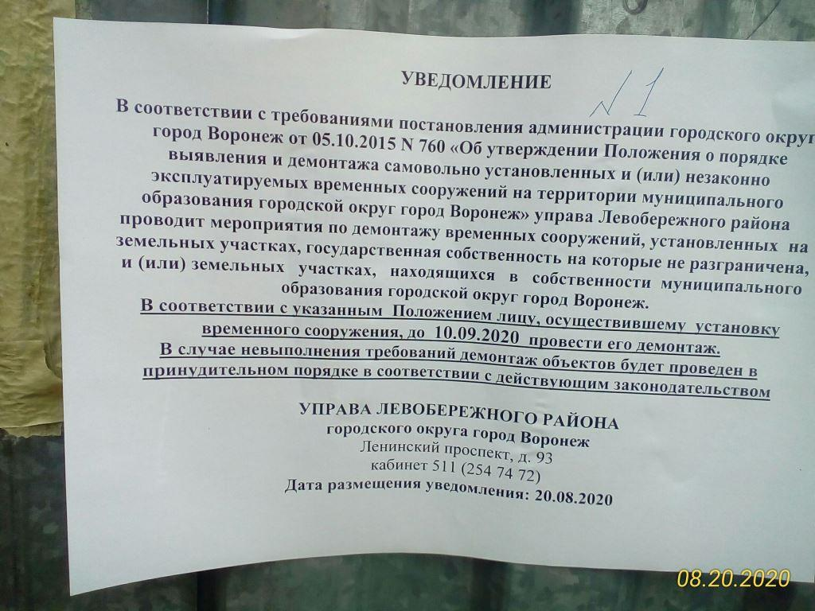

|  |  |  |  |  |
| --- | --- | --- | --- | --- |
| № | Адрес размещения | Дата выявления | Вид временного сооружения (наименование, фото) | Сведения о владельце (ИНН для юр. лиц и ИП, Ф.И.О., адрес) |
|  | пер. Ольховый, 3,9, 9а | 20.08.2020 | C:\Users\ladanilova\AppData\Local\Microsoft\Windows\Temporary Internet Files\Content.Word\P_20200820_095926_1_p.jpg C:\Users\ladanilova\AppData\Local\Microsoft\Windows\Temporary Internet Files\Content.Word\P_20200820_095932_1_p.jpg | Сведения отсутствуют |
|  |  | C:\Users\ladanilova\AppData\Local\Microsoft\Windows\Temporary Internet Files\Content.Word\P_20200820_095959_1_p.jpg C:\Users\ladanilova\AppData\Local\Microsoft\Windows\Temporary Internet Files\Content.Word\P_20200820_100012_1_p.jpg |
|  |  | C:\Users\ladanilova\AppData\Local\Microsoft\Windows\Temporary Internet Files\Content.Word\P_20200820_100033_1_p.jpg C:\Users\ladanilova\AppData\Local\Microsoft\Windows\Temporary Internet Files\Content.Word\P_20200820_100040_1_p.jpg |
|  |  | C:\Users\ladanilova\AppData\Local\Microsoft\Windows\Temporary Internet Files\Content.Word\P_20200820_100053_1_p.jpg C:\Users\ladanilova\AppData\Local\Microsoft\Windows\Temporary Internet Files\Content.Word\P_20200820_100101_1_p.jpg |
|  |  | C:\Users\ladanilova\AppData\Local\Microsoft\Windows\Temporary Internet Files\Content.Word\P_20200820_100130_1_p.jpg C:\Users\ladanilova\AppData\Local\Microsoft\Windows\Temporary Internet Files\Content.Word\P_20200820_100136_1_p.jpg |
|  |  | C:\Users\ladanilova\AppData\Local\Microsoft\Windows\Temporary Internet Files\Content.Word\P_20200820_100153_1_p.jpg C:\Users\ladanilova\AppData\Local\Microsoft\Windows\Temporary Internet Files\Content.Word\P_20200820_100159_1_p.jpg |
|  |  | C:\Users\ladanilova\AppData\Local\Microsoft\Windows\Temporary Internet Files\Content.Word\P_20200820_100209_p.jpg C:\Users\ladanilova\AppData\Local\Microsoft\Windows\Temporary Internet Files\Content.Word\P_20200820_100217_1_p.jpg |
|  |  | C:\Users\ladanilova\AppData\Local\Microsoft\Windows\Temporary Internet Files\Content.Word\P_20200820_100253_1_p.jpg C:\Users\ladanilova\AppData\Local\Microsoft\Windows\Temporary Internet Files\Content.Word\P_20200820_100259_1_p.jpg |
|  |  | C:\Users\ladanilova\AppData\Local\Microsoft\Windows\Temporary Internet Files\Content.Word\P_20200820_100330_1_p.jpg C:\Users\ladanilova\AppData\Local\Microsoft\Windows\Temporary Internet Files\Content.Word\P_20200820_100336_1_p.jpg |
|  |  | C:\Users\ladanilova\AppData\Local\Microsoft\Windows\Temporary Internet Files\Content.Word\P_20200820_100354_1_p.jpg C:\Users\ladanilova\AppData\Local\Microsoft\Windows\Temporary Internet Files\Content.Word\P_20200820_100404_1_p.jpg |
|  |  | C:\Users\ladanilova\AppData\Local\Microsoft\Windows\Temporary Internet Files\Content.Word\P_20200820_100431_1_p.jpg C:\Users\ladanilova\AppData\Local\Microsoft\Windows\Temporary Internet Files\Content.Word\P_20200820_100442_1_p.jpg |
|  |  | C:\Users\ladanilova\AppData\Local\Microsoft\Windows\Temporary Internet Files\Content.Word\P_20200820_100455_1_p.jpg C:\Users\ladanilova\AppData\Local\Microsoft\Windows\Temporary Internet Files\Content.Word\P_20200820_100502_1_p.jpg |
|  |  | C:\Users\ladanilova\AppData\Local\Microsoft\Windows\Temporary Internet Files\Content.Word\P_20200820_100513_1_p.jpg C:\Users\ladanilova\AppData\Local\Microsoft\Windows\Temporary Internet Files\Content.Word\P_20200820_100519_1_p.jpg |
|  |  | C:\Users\ladanilova\AppData\Local\Microsoft\Windows\Temporary Internet Files\Content.Word\P_20200820_100530_1_p.jpg C:\Users\ladanilova\AppData\Local\Microsoft\Windows\Temporary Internet Files\Content.Word\P_20200820_100536_1_p.jpg |
|  |  | C:\Users\ladanilova\AppData\Local\Microsoft\Windows\Temporary Internet Files\Content.Word\P_20200820_100549_1_p.jpg C:\Users\ladanilova\AppData\Local\Microsoft\Windows\Temporary Internet Files\Content.Word\P_20200820_100555_1_p.jpg |
|  |  | C:\Users\ladanilova\AppData\Local\Microsoft\Windows\Temporary Internet Files\Content.Word\P_20200820_100614_1_p.jpg C:\Users\ladanilova\AppData\Local\Microsoft\Windows\Temporary Internet Files\Content.Word\P_20200820_100620_1_p.jpg |
|  |  | C:\Users\ladanilova\AppData\Local\Microsoft\Windows\Temporary Internet Files\Content.Word\P_20200820_100635_1_p.jpg C:\Users\ladanilova\AppData\Local\Microsoft\Windows\Temporary Internet Files\Content.Word\P_20200820_100643_1_p.jpg |
|  |  | C:\Users\ladanilova\AppData\Local\Microsoft\Windows\Temporary Internet Files\Content.Word\P_20200820_100653_1_p.jpg C:\Users\ladanilova\AppData\Local\Microsoft\Windows\Temporary Internet Files\Content.Word\P_20200820_100703_1_p.jpg |
|  |  | C:\Users\ladanilova\AppData\Local\Microsoft\Windows\Temporary Internet Files\Content.Word\P_20200820_100712_1_p.jpg C:\Users\ladanilova\AppData\Local\Microsoft\Windows\Temporary Internet Files\Content.Word\P_20200820_100722_1_p.jpg |
|  |  | C:\Users\ladanilova\AppData\Local\Microsoft\Windows\Temporary Internet Files\Content.Word\P_20200820_100730_1_p.jpg C:\Users\ladanilova\AppData\Local\Microsoft\Windows\Temporary Internet Files\Content.Word\P_20200820_100736_1_p.jpg |
|  |  | C:\Users\ladanilova\AppData\Local\Microsoft\Windows\Temporary Internet Files\Content.Word\P_20200820_100818_1_p.jpg C:\Users\ladanilova\AppData\Local\Microsoft\Windows\Temporary Internet Files\Content.Word\P_20200820_100824_1_p.jpg |
|  |  | C:\Users\ladanilova\AppData\Local\Microsoft\Windows\Temporary Internet Files\Content.Word\P_20200820_100834_1_p.jpg C:\Users\ladanilova\AppData\Local\Microsoft\Windows\Temporary Internet Files\Content.Word\P_20200820_100844_1_p.jpg |